ASR 2244

1) To include the 20” & 40” footer info into the “Shipment Analysis by Destination”

2) To have a selection in the Non-EMC ASN creation screen so that the receiving team can key in total container size

1) Outbound
Currently, we run the “Shipment analysis by destination” first and then go to “Shipment Tracking” to filter out customer by customer to see the total 20” & 40” footer containers shipped.

Can you please include the 20” & 40” footer info into the “Shipment Analysis by Destination” similar to the data reflected in “Shipment Tracking” (data entered in SI/SA Outbound Maintenance). I have attached an Excel sheet as to how it should look like when extracted (Outbound Freight Data Test).
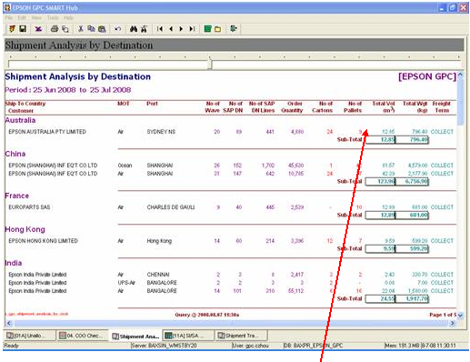
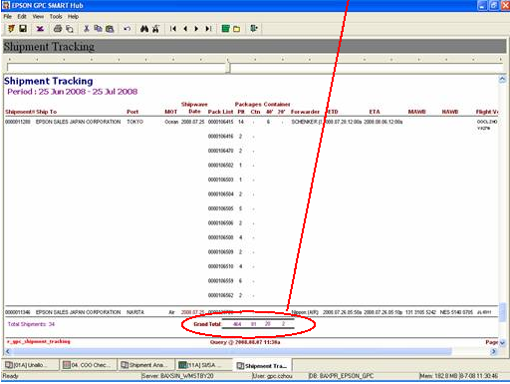

2) Inbound

For inbound, currently we run the “Expected Incoming” first and then go to our own excel records to find the total 20” & 40” footer containers unstuffed.
This is very tedious as currently I believe we did not indicate the container size during the receiving process.

So can we capture the data in the system? Please have a selection or something in the Non-EMC ASN creation screen so that the receiving team can key in the container size.
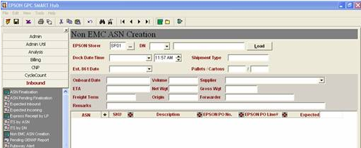
20ft Container: _____
40ft Container: _____

After which, likewise this container size info has to be reflected in the Expected Incoming Screen.

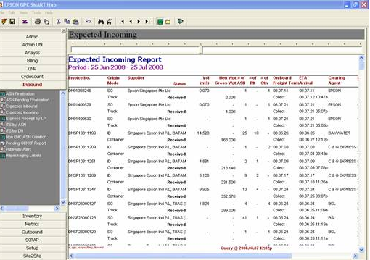

COMPLETED: [2008.08.25]
1. Outbound – Shipment Analysis
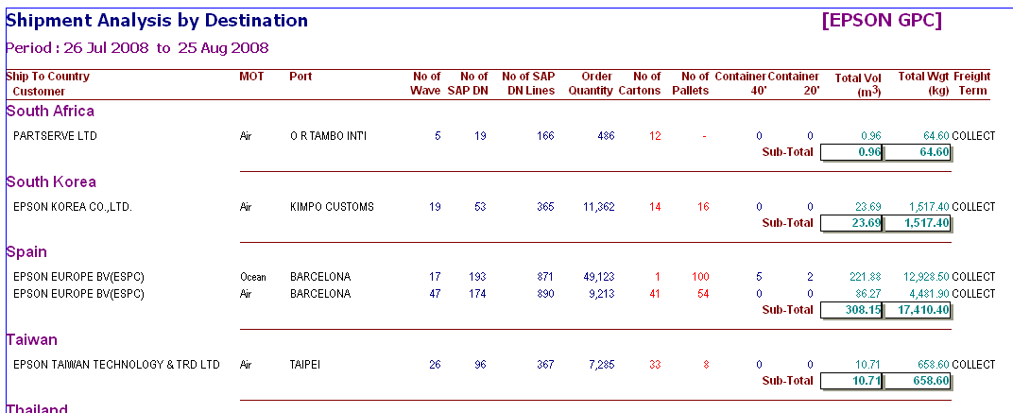

2. Inbound

2.1 ASN Creation
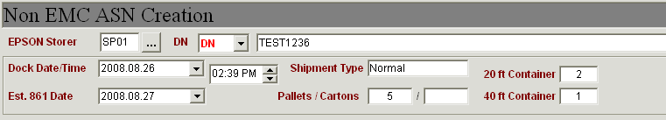

2.2 Expected Incoming
